P50 Pocket Ultrasound System Technical Specifications
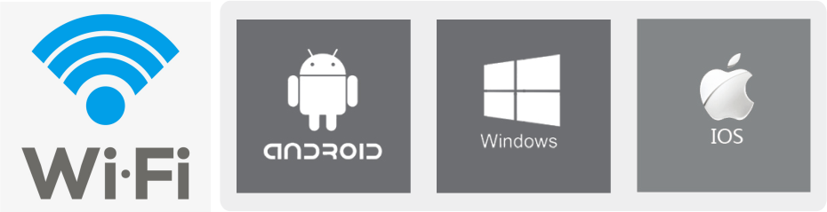
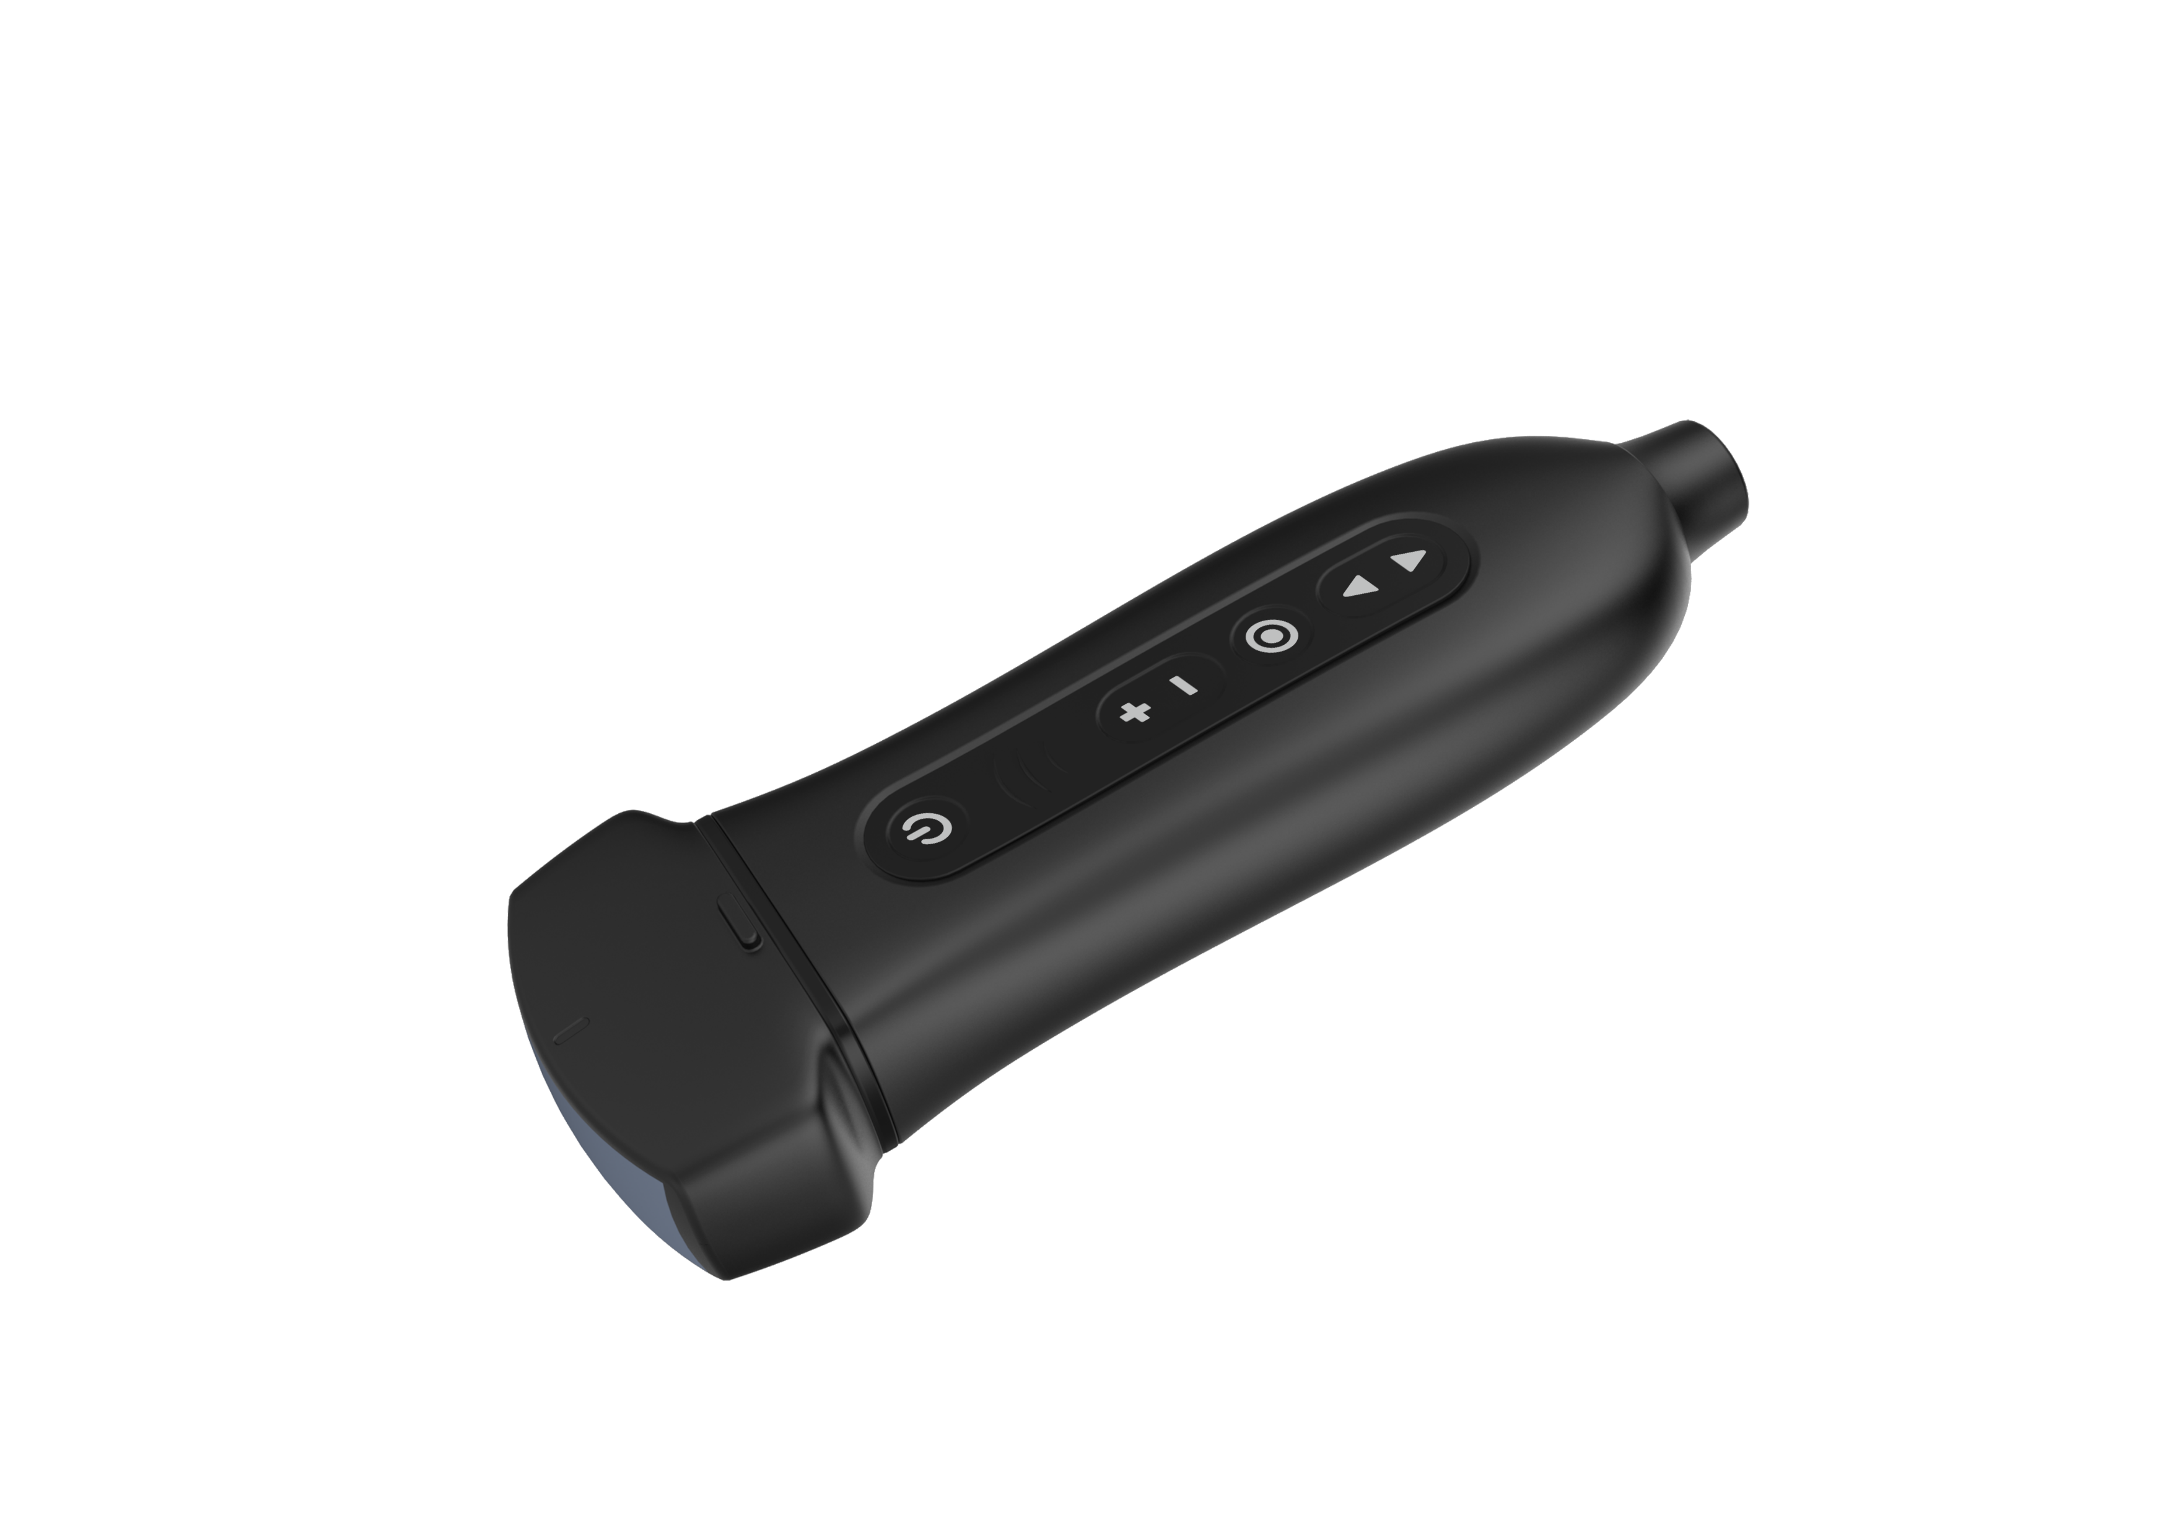
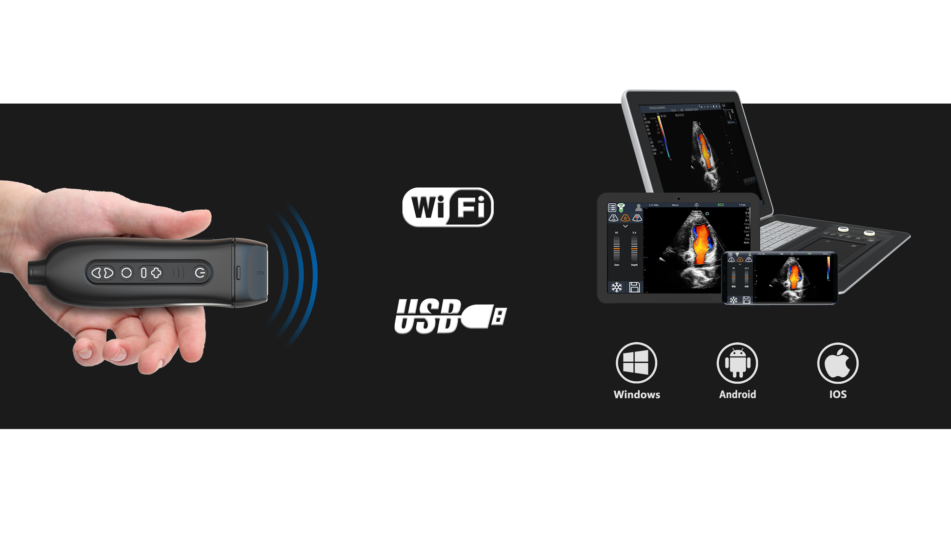
Design of the innovation
- Wireless connection between ultrasound probe and display
Any conventional tablets can transform into an ultrasound machine (Supports IOS, Android and windows). Images can be shared within one click.
- An ultrasound machine with only 160g light weight, Convenient for hand-carry to anywhere.
- Patented detachable probe head and main unit
More cost effective and convenient to meet the needs of different clinical applications. Freeze, unplug, plug, 3 steps to detach probe lens for different applications.

general specifications
Net weight: About 160g
Size: 150mm*40mm*25mm
Battery time: About 4 hours
Waterproof level: Ipx4
WIF coverage distance: ≥6m

Platform: Android, Windows, IOS
Connection Type: 2.4G/5G 802.11b/g/a WiFi &USB
Supporting devices: Android tablet or smart phone, Windows PC, IPhone and IPAD.
Probe heads: All types of detachable transducers supported.
Modes: B, M, 2B, THI, Color, Power, PW
(only color Doppler version have Color, Power, PW)
Gray level: 256
Transducer Frequency: 2-11MHz
Max scanning Depth: 310mm
Dynamic range: 30-120

Digital Technology: Wide-angle imaging
Panoramic focusing technology
Frequency compounding
Space compounding
Rolling M technology
Real-time Dynamic Aperture
Tissue Harmonic Imaging
Tissue Specific Imaging

Controls:
Gain TGC Depth
C Scale/Vel
C Gain
C Frequency
C Steer

PW Steer
PW SV Size
PW BaseLine
Time Mark(Only Windows)
PW Speed
PW Auto Calculation
PW Auto Calculation Parameters
Frequency
Focus Position
Dynamic Range
Frame Correlation/Persistence
TSI
Enhance
Gray Map
Acoustic Power
Qbeam/CrossBeam
Expand mode
Biopsy GuideLine
Left/Right Flip
Up/Down Flip

Function
Cine-loop: 400 frames movie playback stored
Zoom: Max 10 times
Qopt: One-key optimization
Language: Chinese, English, (All systems)
Russian, Spanish, Italian, Czech, German (Windows&Android)
DICOM: DICOM 3.0
Other function: Patient information Management

Measurement and calculation
B mode: Distance, angle, area, volume,
trace length, distance ratio, area ratio, histogram
M mode: Distance, time, slope, heart rate
CALCULATION PACKAGES:
Ob/Gyn: Measurements: Distance/Ellipse/Trace/Volume, GS, CRL, BPD, HC, AC, FL, AFI, Cervix Length,
Calculations: Estimated Fetal Weight, Estimated Due Date
Cardiac:
Measurements: Distance/Ellipse/Trace/Area, RVWd, RVDd, IVSd, LVDd, LVPWd, RVWs, RVDs, IVSs, LVPWs, MVA, AVA
Calculations: Ejection Fraction, Fractional Shortening, Volume Area, Stroke Volume, LA/Ao, CI, SI
(Above items are for Windows APP. For Android and IOS APP, the measurements include Distance, Angle, Area, Time, Heart Rate, Speed)
Full measurement packages, report and patient list support only for Windows
Application package:
Abdomen, Small parts, Vascular, Obstetrics,
Gynecology, Cardiology, Kidney,
Urology, Orthopedics, Carotid, MSK, Nerve

Software Compatibility
iOS: iOS version 10.0 or newer
Suggested Mobile devices: iPhone 5S (or newer), iPod Touch (5th gen or newer)
Apple iPhone 6s, 6s Plus, SE, 7, 7 Plus, 8, 8 Plus, X, XS, XS Max and XR
Suggested Tablet device:iPad (3rd gen or newer), iPad Air (1st gen or newer), iPad Mini (1st gen or newer),
iPad 5th gen, 6th gen, iPad Pro
Android: Android device 7.0 or newer
Suggested Mobile devices: HUAWEI mate 8, mate 9, mate 20, mate 30, P10, P20, P30, Honor..
Suggested Tablet device: HUAWEI MediaPad M6, Matepad, Matepad Pro,
Samsung Galaxy Tab S5e, S6, S7+, Samsung Galaxy Tab A(2019), Samsung Galaxy Tab A7 …
Baaske e-medic tablet, Teguar TMT-4391-08
Windows:
Windows XP, Win7, Win8, Win10 PC (At least i5 CPU and 4GB memory)
Suggested Windows device: Huawei MateBook 13, MateBook 14, MateBook X Pro,
Microsoft Surface GO 2, Microsoft Surface GO 3, Microsoft Surface Pro.

Working Power Supply
AC Adaptor output: Voltage 5V, Output current 2A
Battery: Lithium-Ion Battery Pack: 7.4V, 1300mAh
Recharge time: About 2 hours(for full recharge)
Scan time: About 4 hours continuous scanning time
System Bootup: Less than 5 seconds

Working Environment
Ambient Temperature: 0℃-32℃
Relative Humidity: 30%-85%
Atmospheric Pressure: 700hPa-1060hPa

Multiple frequency probes
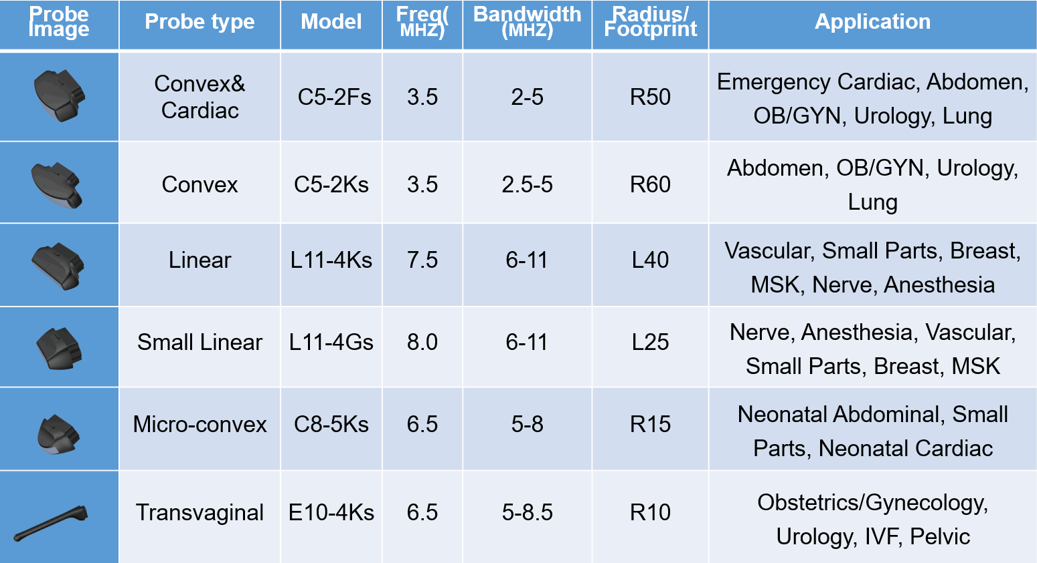

Standard Configurations
Wireless system main unit
One Probe head
APP software
Power Adapter
Type-C cable
carrying case
24 months warranty since ex-factory date for main unit
12 months warranty since ex-factory date for probe heads

Contact US：
Guangdong Youkey Medical Co., Ltd.
E-mail: arvinleung@youkeymedical.com
Web: www.youkeymedical.com

